Trends in urban flows: from Wi-Fi data to pedestrians' route choices

I. INTRODUCTION

The accurate estimation of human activity in cities is one of the first steps towards understanding the structure of the urban environment [1]. Human activities are highly granular and dynamic in both the spatial and temporal dimensions [2] and estimating them with confidence is crucial for decision-making in numerous applications such as urban management, retail, transport planning and emergency management. Detecting general trends in flow of people between spatial locations is neither obvious nor an easy task due the high cost of capturing these movements without compromising the privacy of those involved. This research intends to address this problem by examining the movement of people in a SmartStreetSensors network at a fine spatial and temporal resolution. A novel methodology to the field of Big Data using mathematical models from information theory is introduced.

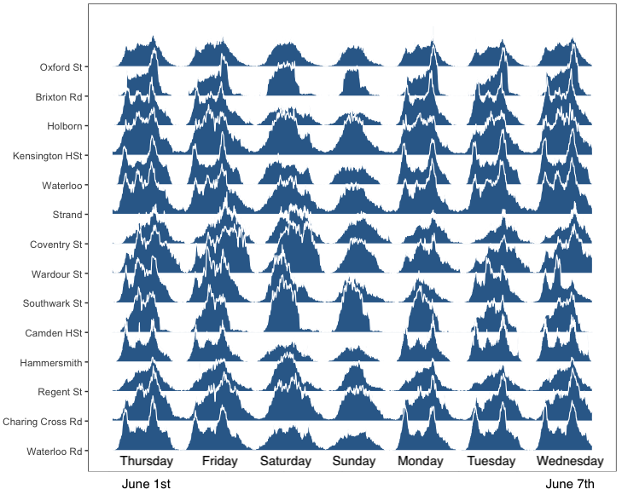

Figure 1. A week of measures at fourteen London locations where it is clear that different locations produce different Footfall signals.

II. DATA

The SmartStreetSensor project is one of the most comprehensive studies undertaken on consumer volume and characteristics in retail areas across United Kingdom. The data for the study is generated through sensors installed at around 1000 locations across UK. These sensors capture a series of public signals - known as probe request frames - generated by Wi-Fi enable devices. The number of probe requests captured is in the order of 2.6 billion records and growing at a rate of 6 million new requests per day. Each sensor generates a stationary time series representing footfall counts around a particular location throughout the day in 5-minute intervals. Figure 1

III. RESULTS

The aim is to, without actually tracking people, provide a measure for the size of the flow between each pair of sensors. We took the subnetwork of the sensors that are within a 5-minute walking distance from each other and workout the daily pairwise correlation for each pair. Then, we estimated the flows of people between them thinking on this motion of people as flows of information among distinctive sources, so we can relate the number of people reaching one sensor from another by measuring the uncertainty between two interacting random variables. For this, we used an information theory concept known as Transfer Entropy *TE* [3] defined by:

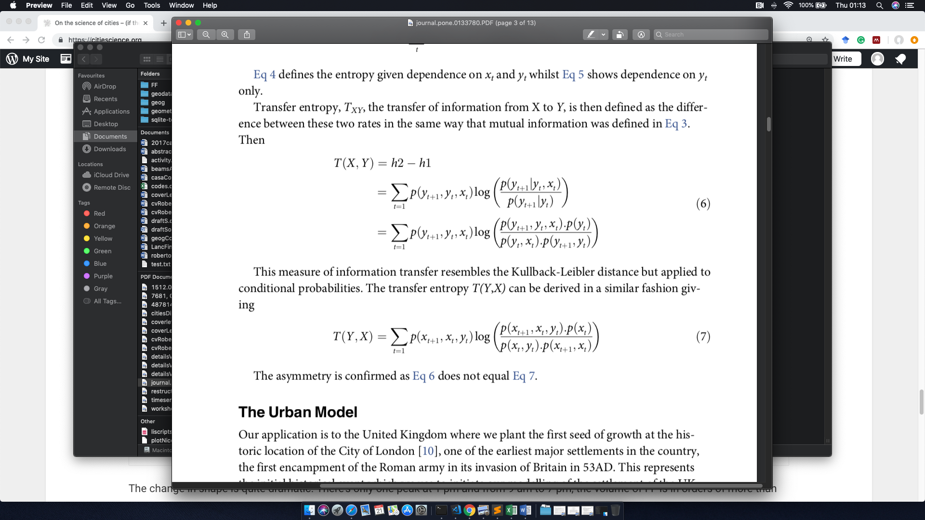(1)

Where t indicates a given point in time. Basically, Eq. 1 measures the reduction in uncertainty at yt, given xt and yt−1 in comparison with the case when only yt−1 is known.

REFERENCES

[1] Louail, T. et al., 2014. From mobile phone data to the spatial structure of cities. arXiv:1401.4540v1 [physics.soc-ph], 18, pp.114.

[2] Steenbruggen, J. et al., 2013. Mobile phone data from GSM networks for traffic parameter and urban spatial pattern assessment: a review of applications and opportunities. GeoJournal, 78(2), pp.223243.

[3] Schreiber T. (2000). Measuring Information Transfer Phys. Rev. Lett. , 85,461464